**Detection of COVID-19 from Chest X-Ray Images Using Convolutional Neural Networks**

**INTRODUCTION:**

At the end of 2019, humankind was faced with an epidemic—severe acute respiratory syndrome coronavirus 2 (SARS CoV-2)–related pneumonia, referred to as coronavirus disease 2019 (COVID-19)—that people did not expect to encounter in the current era of technology. While the COVID-19 outbreak started in Wuhan, China, the significant spread of the epidemic around the world has meant that the amount of equipment available to doctors fighting the disease is insufficient. At the time of writing (September 8, 2020), there have been more than 27,000,000 confirmed cases and more than 875,000 confirmed deaths worldwide.1 Considering the time required for diagnosis and the financial costs of the laboratory kits used for diagnosis, artificial intelligence (AI) and deep learning research and applications have been initiated to support doctors who aim to treat patients and fight the illness.2 Although rapid point-of-care COVID-19 tests are expected to be used in clinical settings at some point, for now, turnaround times for COVID-19 test results range from 3 to more than 48 hours, and probably not all countries will have access to those test kits that give results rapidly. According to a recently published multinational consensus statement by the Fleischner Society, one of the main recommendations is to use chest radiography for patients with COVID-19 in a resource-constrained environment when access to computed tomography (CT) is limited.3 The financial costs of the laboratory kits used for diagnosis, especially for developing and underdeveloped countries, are a significant issue when fighting the illness. According to their previously mentioned statement,3 the Fleischner Society recommends that medical practitioners use chest X-ray and CT in the management of COVID-19. In the end, the choice of imaging modality is left to the judgment of clinical teams at the point of care, accounting for the differing attributes of chest radiography and CT, local resources, and expertise. In this study, we propose the use of chest X-ray images over CT of the thorax, considering the latter’s required diagnostic time. A CT scan of the thorax takes significantly more time than a chest X-ray scan does, and this means more contact duration with suspected or confirmed COVID-19 patients.

**ABSTRACT:**

The detection of severe acute respiratory syndrome coronavirus 2 (SARS CoV-2), which is responsible for coronavirus disease 2019 (COVID-19), using chest X-ray images has life-saving importance for both patients and doctors. In addition, in countries that are unable to purchase laboratory kits for testing, this becomes even more vital. In this study, we aimed to present the use of deep learning for the high-accuracy detection of COVID-19 using chest X-ray images. Publicly available X-ray images (1583 healthy, 4292 pneumonia, and 225 confirmed COVID-19) were used in the experiments, which involved the training of deep learning and machine learning classifiers. Thirty-eight experiments were performed using convolutional neural networks, 10 experiments were performed using five machine learning models, and 14 experiments were performed using the state-of-the-art pre-trained networks for transfer learning. Images and statistical data were considered separately in the experiments to evaluate the performances of models, and eightfold cross-validation was used. A mean sensitivity of 93.84%, mean specificity of 99.18%, mean accuracy of 98.50%, and mean receiver operating characteristics–area under the curve scores of 96.51% are achieved. A convolutional neural network without pre-processing and with minimized layers is capable of detecting COVID-19 in a limited number of, and in imbalanced, chest X-ray images.

**EXISTING SYSTEM:**

According to a recently published multinational consensus statement by the Fleischner Society, one of the main recommendations is to use chest radiography for patients with COVID-19 in a resource-constrained environment when access to computed tomography (CT) is limited. The financial costs of the laboratory kits used for diagnosis, especially for developing and underdeveloped countries, are a significant issue when fighting the illness. Using X-ray images for the automated detection of COVID-19 might be helpful in particular for countries and hospitals that are unable to purchase a laboratory kit for tests or that do not have a CT scanner. This is significant because, currently, no effective treatment option has been found, and therefore effective diagnosis is critical.

**Disadvantages:**

* computed tomography (CT) is limited
* unable to purchase a laboratory kit for tests or that do not have a CT scanner
* no effective treatment option has been found, and therefore effective diagnosis is critical

**PROPOSED SYSTEM:**

we aimed to present the use of deep learning for the high-accuracy detection of COVID-19 using chest X-ray images. Publicly available X-ray images (1583 healthy, 4292 pneumonia, and 225 confirmed COVID-19) were used in the experiments, which involved the training of deep learning and machine learning classifiers. Thirty-eight experiments were performed using convolutional neural networks, 10 experiments were performed using five machine learning models, and 14 experiments were performed using the state-of-the-art pre-trained networks for transfer learning. Images and statistical data were considered separately in the experiments to evaluate the performances of models, and eightfold cross-validation was used. A mean sensitivity of 93.84%, mean specificity of 99.18%, mean accuracy of 98.50%, and mean receiver operating characteristics–area under the curve scores of 96.51% are achieved. A convolutional neural network without pre-processing and with minimized layers is capable of detecting COVID-19 in a limited number of, and in imbalanced, chest X-ray images.

**Advantages:**

* Accuracy is high
* A convolutional neural network without pre-processing and with minimized layers is capable of detecting COVID-19 in a limited number of, and in imbalanced, chest X-ray images.

**REQUIREMENTS:**

The following are the hardware and software requirements that have used to implement the proposed system

**HARDWARE REQUIREMENTS:**

* System : Pentium IV 2.4 GHz.
* Hard Disk : 40 GB.
* Floppy Drive : 1.44 Mb.
* Monitor : 15 VGA Colour.
* Mouse : Logitech.
* Ram : 512 Mb.

**SOFTWARE REQUIREMENTS:**

* **Operating System:** Windows
* **Coding Language**: Python

**SYSTEM ARCHITECTURE:**

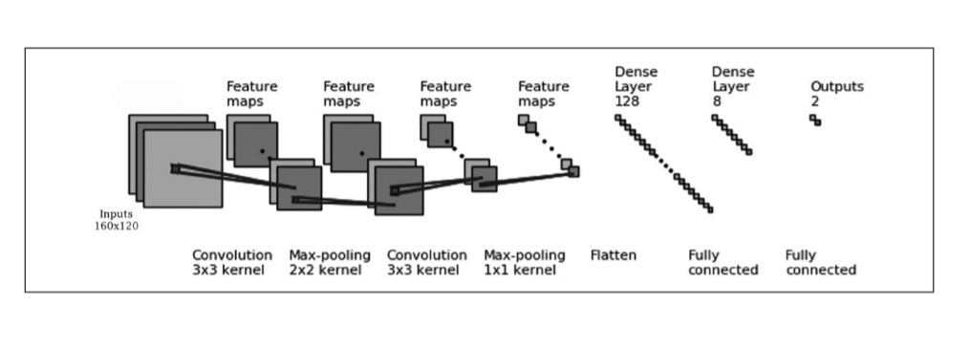

**CONCLUSION:**

Detection of COVID-19 from chest X-ray images is of vital importance for both doctors and patients to decrease the diagnostic time and reduce financial costs. Artificial intelligence and deep learning are capable of recognizing images for the tasks taught. In this study, several experiments were performed for the high-accuracy detection of COVID-19 in chest X-ray images using ConvNets. Various groups—COVID-19/Normal, COVID-19/Pneumonia, and COVID-19/Pneumonia/Normal— were considered for the classification. Different image dimensions, different network architectures, state-of-the-art pre-trained networks, and machine learning models were implemented and evaluated using images and statistical data. When the number of images in the database and the detection time of COVID-19 (average testing time = 0.03 s/image) are considered using ConvNets, it can be suggested that the considered architectures reduce the computational cost with high performance. The results showed that the convolutional neural network with minimized convolutional and fully connected layers is capable of detecting COVID-19 images within the two-class, COVID-19/Normal and COVID-19/Pneumonia classifications, with mean ROC AUC scores of 96.51 and 96.33%, respectively. In addition, the second proposed architecture, which had the second-lightest architecture, is capable of detecting COVID-19 in three-class, COVID-19/Pneumonia/Normal images, with a macro-averaged F1score of 94.10%. Therefore, the use of AI-based automated high-accuracy technologies may provide valuable assistance to doctors in diagnosing COVID-19. Further studies, based on the results obtained in this study, would provide more information about the use of CNN architectures with COVID-19 chest X-ray images and improve on the results of this study.

.